Instruction—Safety and Security

Our web application—MediaWiki runs on Google Cloud Platform, and we use a lot of google cloud API to automatic the installation.

There are two parts in instruction,

part 1 – Installation Guide;

part 2 – Test;

# Installation Guide

To successfully install our web application, perform the following steps:

1. Create a Google Cloud account
2. Create a project
3. Create the manager instance

gcloud beta compute instances create manager-instance --zone=australia-southeast1-b --machine-type=n1-standard-1 --subnet=default --network-tier=PREMIUM --maintenance-policy=MIGRATE --scopes=https://www.googleapis.com/auth/cloud-platform --image=ubuntu-1604-xenial-v20180912 --image-project=ubuntu-os-cloud --boot-disk-size=10GB --boot-disk-type=pd-standard

1. Copy zip file

scp /path/your_zip_file root@instance_external_ip:/root

1. Connect the manager-instance
2. Run scripts

sudo su

cd ~

apt -y install unzip

unzip ~/2018_Group_8_task3.zip

bash ~/2018_Group_8/safetyandsecurity/install.sh

The admin user: username: admin password: adminadmin

## Create a Google Cloud account

It is as same as your Google Account.

Note: If you do not have a Google Account, you can see the [Help](https://support.google.com/accounts/answer/27441?hl=en) page.

## Create a project

Open the browser, visit Google Cloud <https://cloud.google.com/>, Sign in, and click the “Console”.

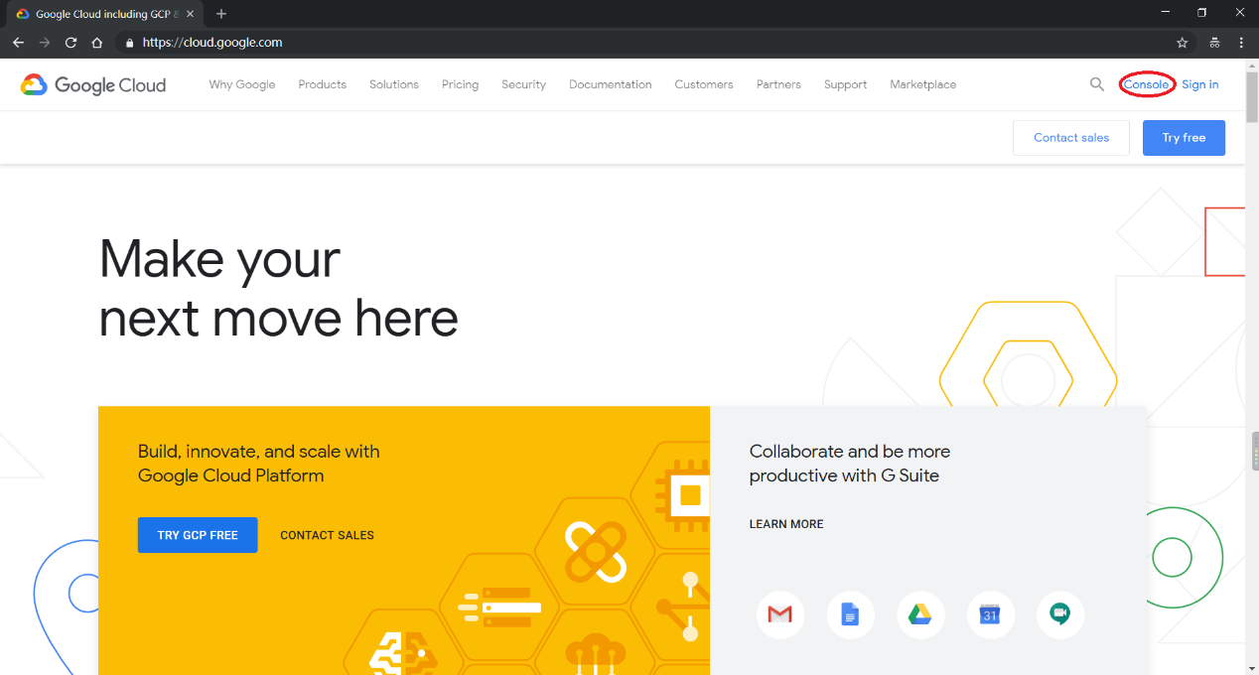

After that, you can see google gives the new user $300 credit to use, click ACTIVATE.

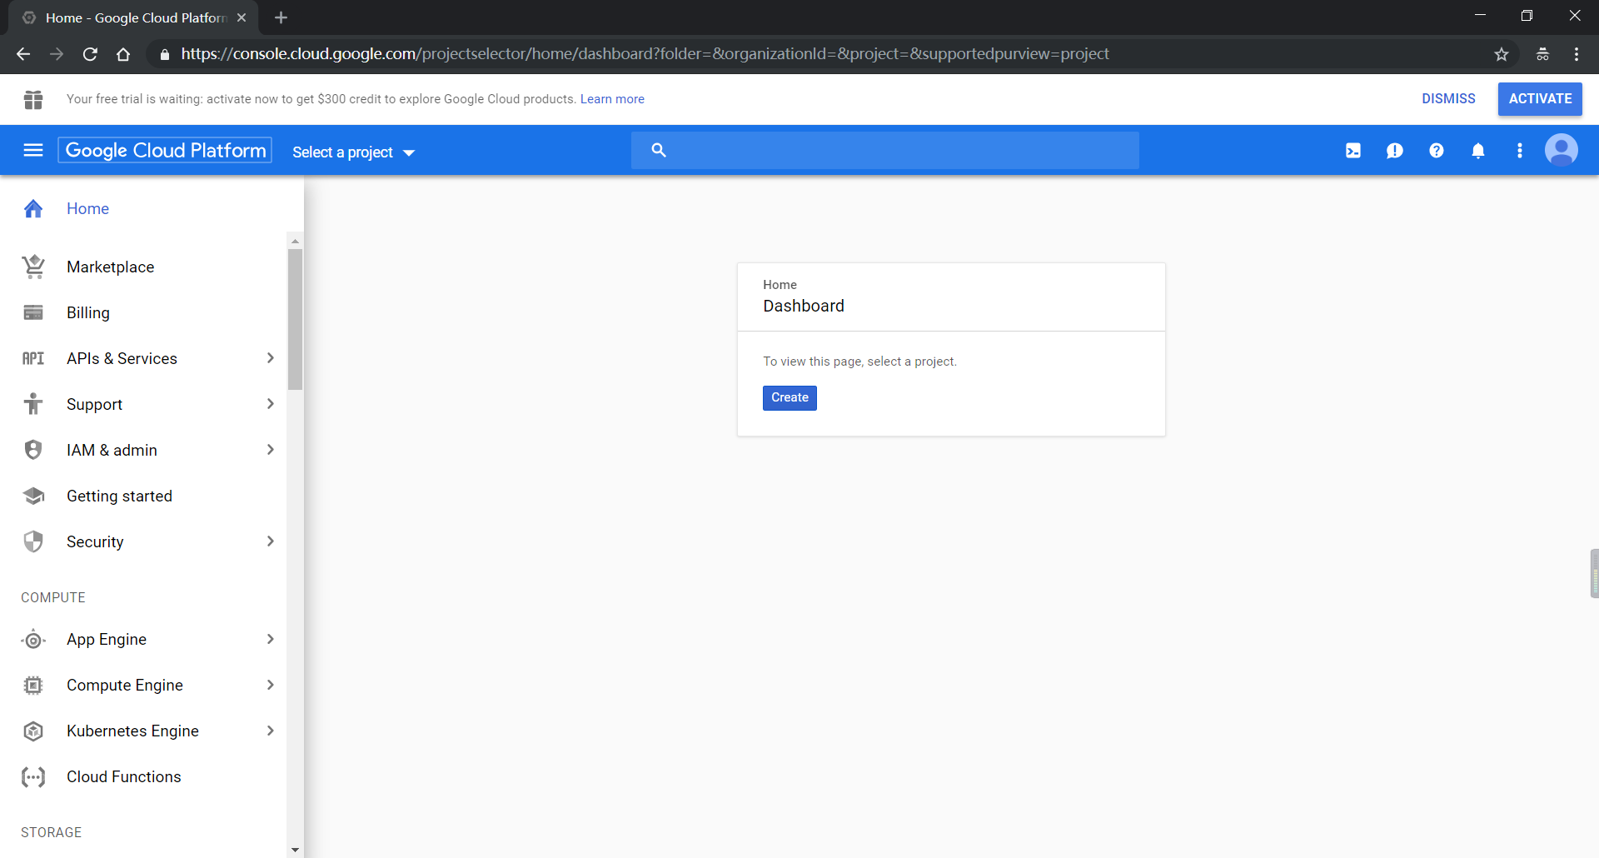

Then, you need to fill in the blanks and get $300 credits.

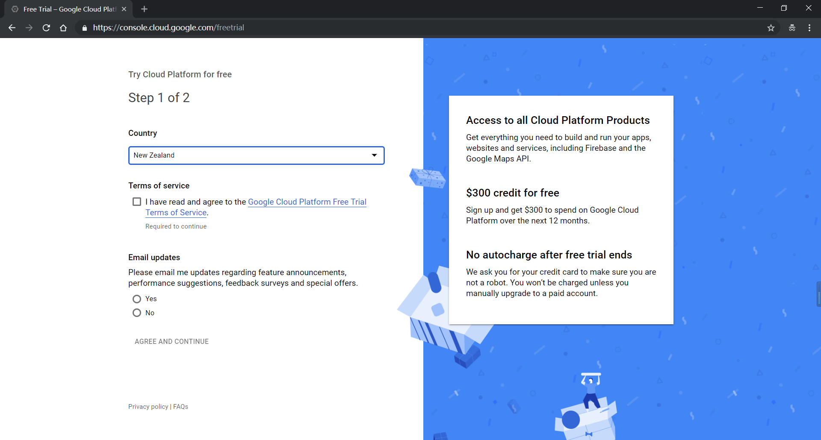

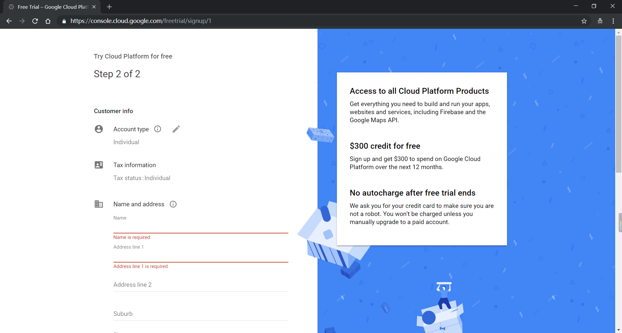

Now create a project;

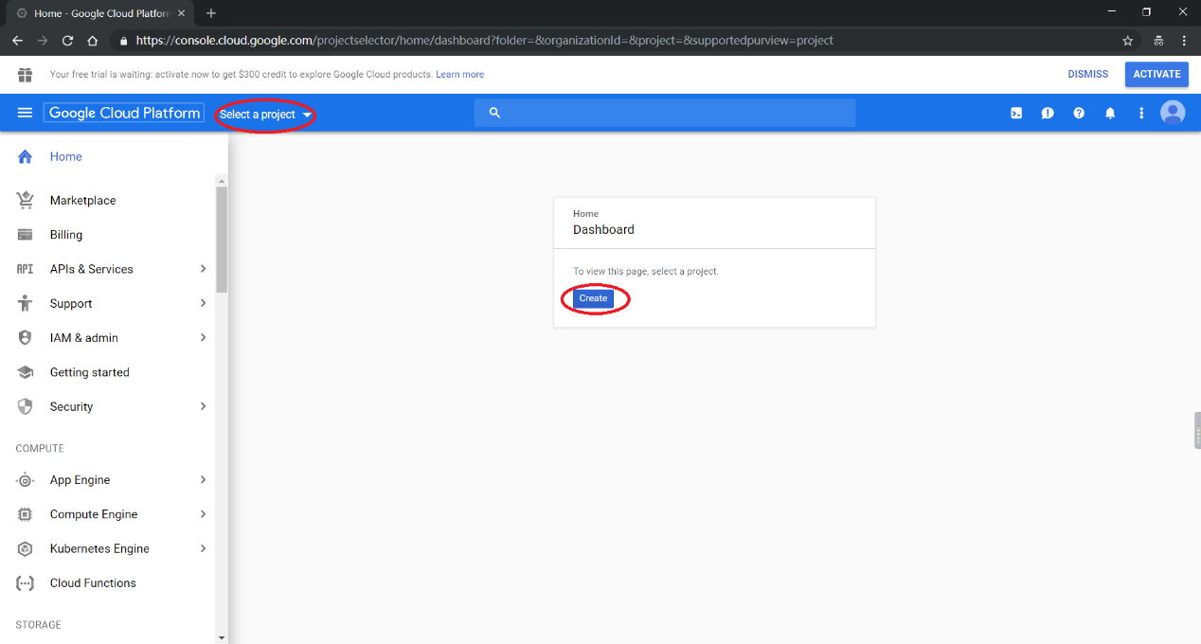

Give the project name and create;

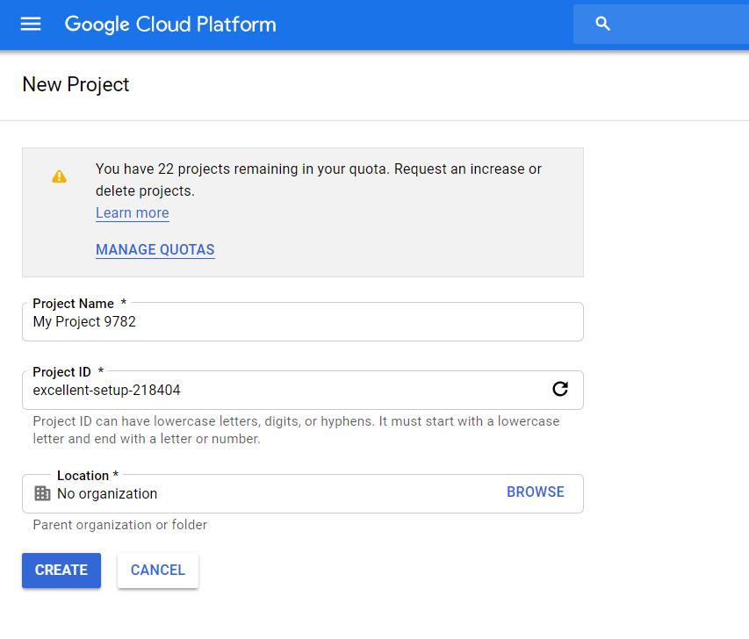

Then, go to Compute Engine item, it takes a minute to initialize the API

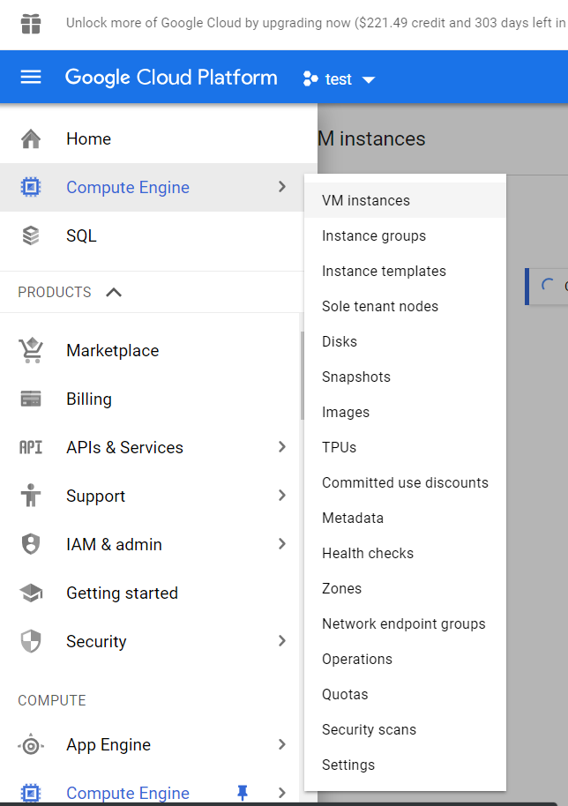

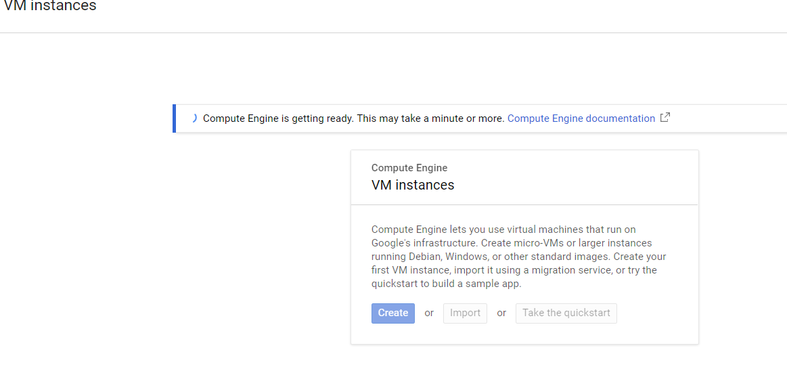

After initialization, you can create a VM instance.

## Create manager instance

Now, you can create an instance by two way,

* 1. Using Activate Google Shell

In the picture below, on the top-right corner, click it.

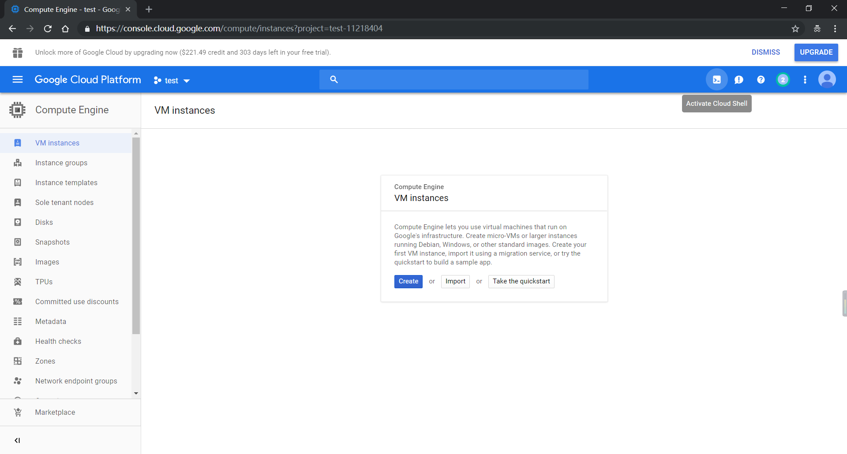

Waiting for connection, then you can copy the command below to create a manager instance.

gcloud beta compute instances create manager-instance --zone=australia-southeast1-b --machine-type=n1-standard-1 --subnet=default --network-tier=PREMIUM --maintenance-policy=MIGRATE --scopes=https://www.googleapis.com/auth/cloud-platform --image=ubuntu-1604-xenial-v20180912 --image-project=ubuntu-os-cloud --boot-disk-size=10GB --boot-disk-type=pd-standard

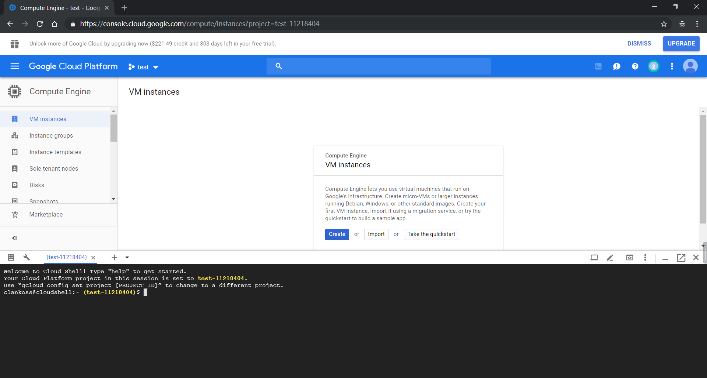

* 1. Step by step creation

Click “Create”;

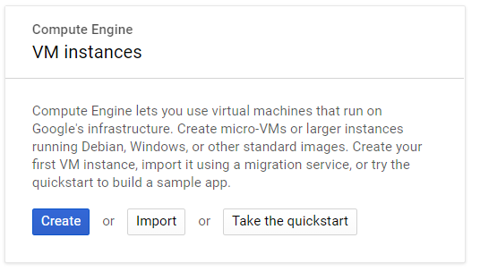

And set variables as follows:

* Name: manager-instance
* Region: australia-southeast1-b
* Machine Type: 1vCPU (n1-standard-1)
* Boot Disk: Ubuntu 16.04 LTS (ubuntu-1604-xenial-v20180912)
* Identity and API access:
  + Service account: Compute Engine default service account
  + Access scopes: Allow full access to all Cloud APIs **VERY IMPORTANT**

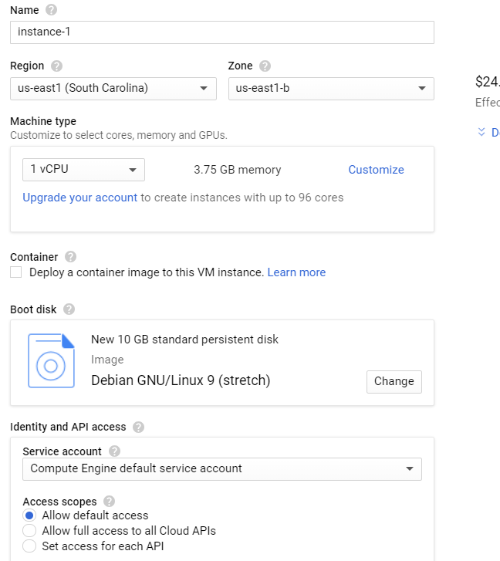

## Copy zip file to instance /root/ directory.

In this step, we will generate your computer’s public key and put it into google cloud metadata for ssh connection.

In windows, open Windows PowerShell or any other linux shell tools.

Input ssh-keygen, press Enter for 3 times

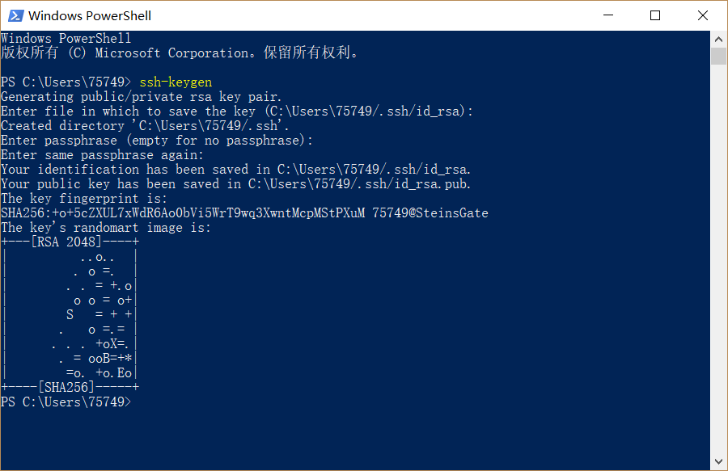

Then input cat ./.ssh/id_rsa.pub, copy the lines below

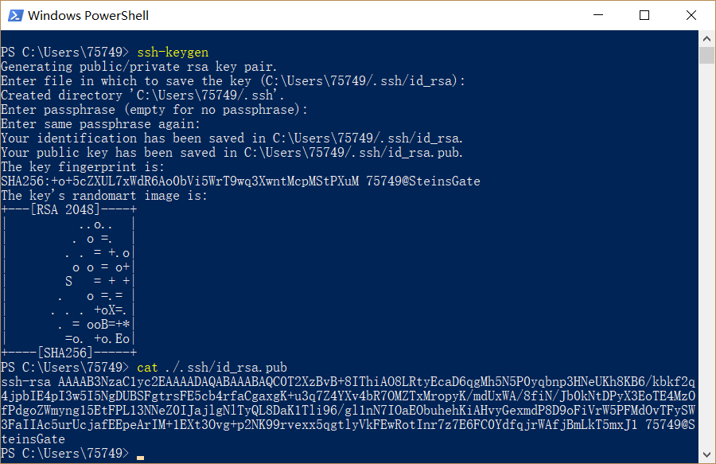

Then back to Google Cloud, go to Metadata, SSH keys folder, click Edit

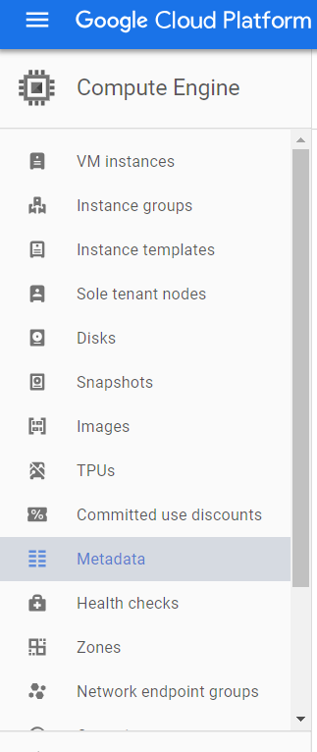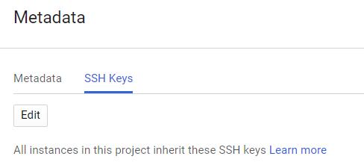

Click Add item and paste your public key, click Save

NOTE: Change the username(before the @) to “root”

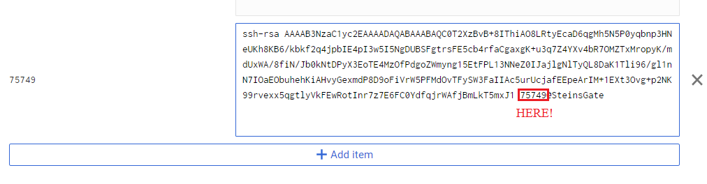

After saving, it shows like this:

Then back to PowerShell input

scp /path/your_zip_file root@instance_external_ip:/root For example, my zip path is C:\Users\75749\Downloads\2018_Group_8.zip , my instance_ip is 35.189.62.140

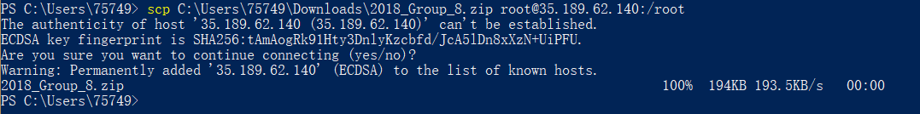

NOTE: If this is your first time ssh to instance, it will ask you for confirm; Enter “yes” for it.

## Connect the manager-instance

SSH to manager-instance, you can use Google provided SSH to the instance.

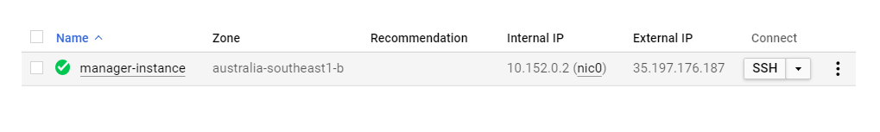

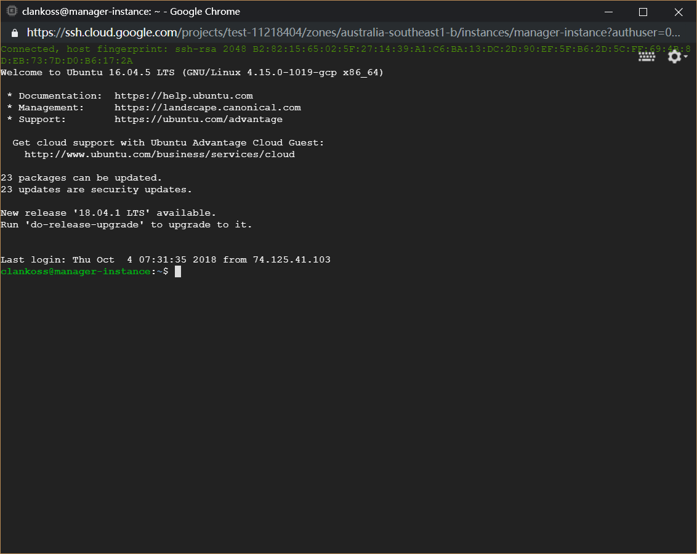

Or also using PowerShell

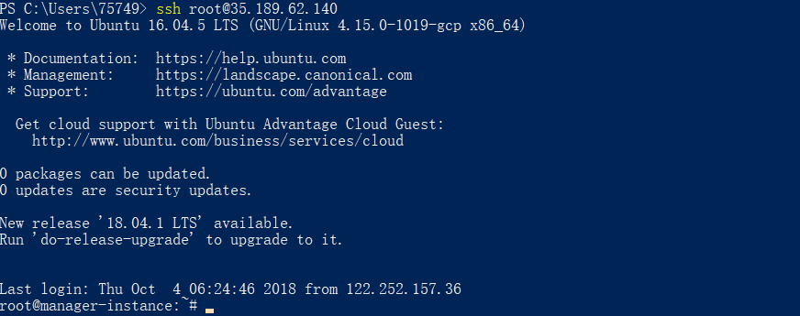

## Run scripts

sudo su

cd ~

apt -y install unzip

unzip ~/2018_Group_8_task3.zip

bash ~/2018_Group_8/safetyandsecurity/install.sh

Then, waiting a few minutes, you can click the underline to visit our web application.

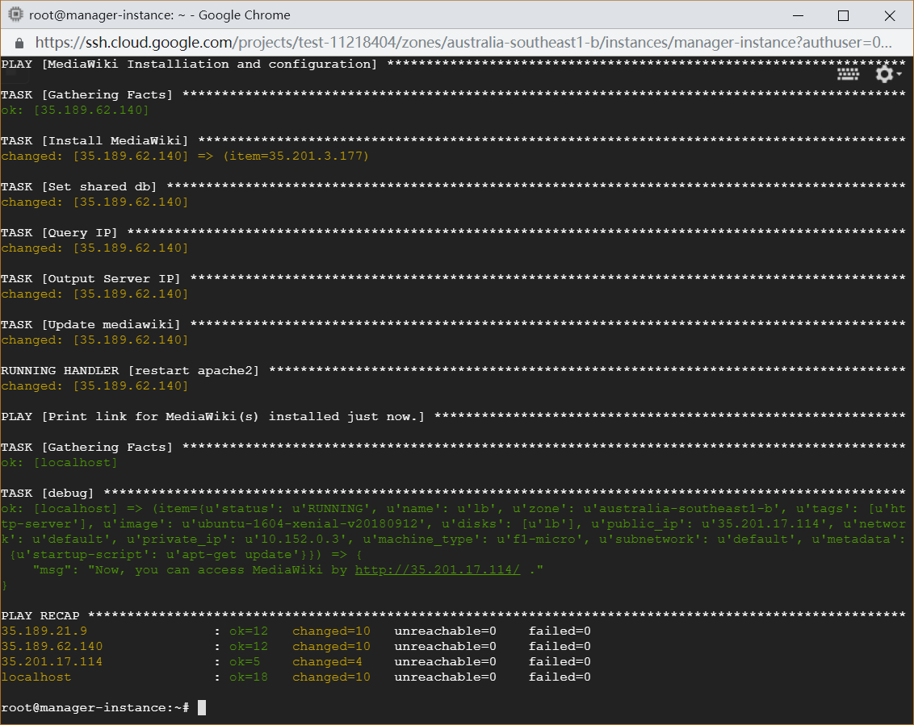



Ignore the privacy error and Proceed to ip:

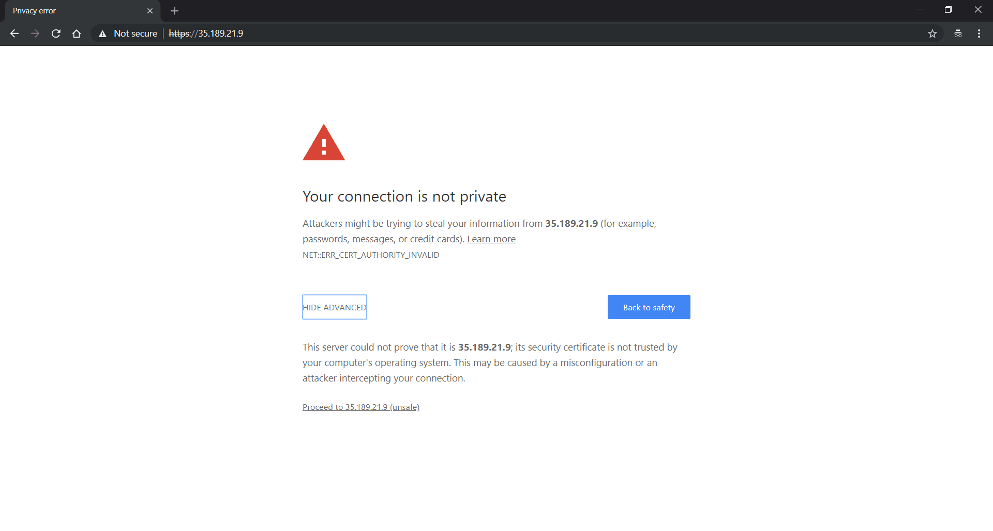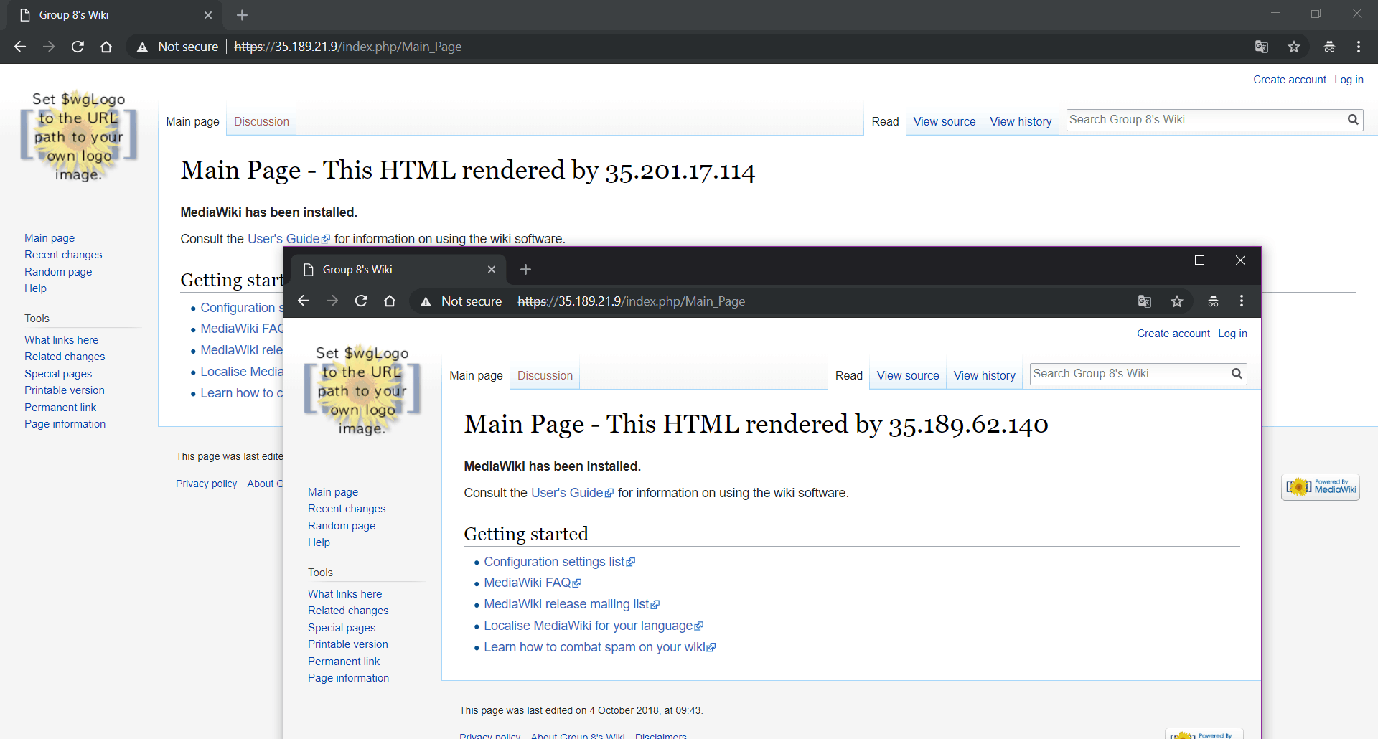

NOTE: The admin user: username: admin password: adminadmin

NOTE: If you have issues when running the “Download ConfirmEdit” task, it is caused by the network issue that means you cannot download this file. You can check this link:

<https://extdist.wmflabs.org/dist/extensions/ConfirmEdit-REL1_31-b52469c.tar.gz>

If you can download this file successfully, please try again.

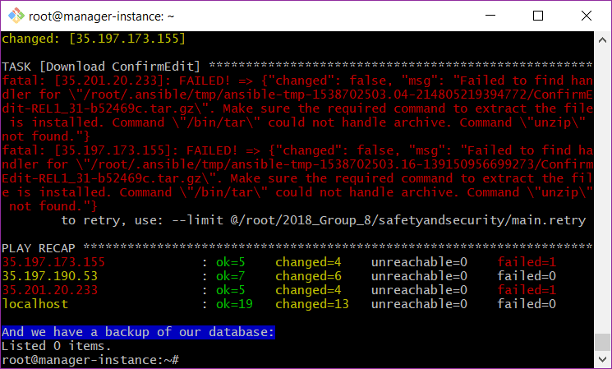

# Test

You can see the difference between two web pages, the former is the one added config variables, and the latter is not.

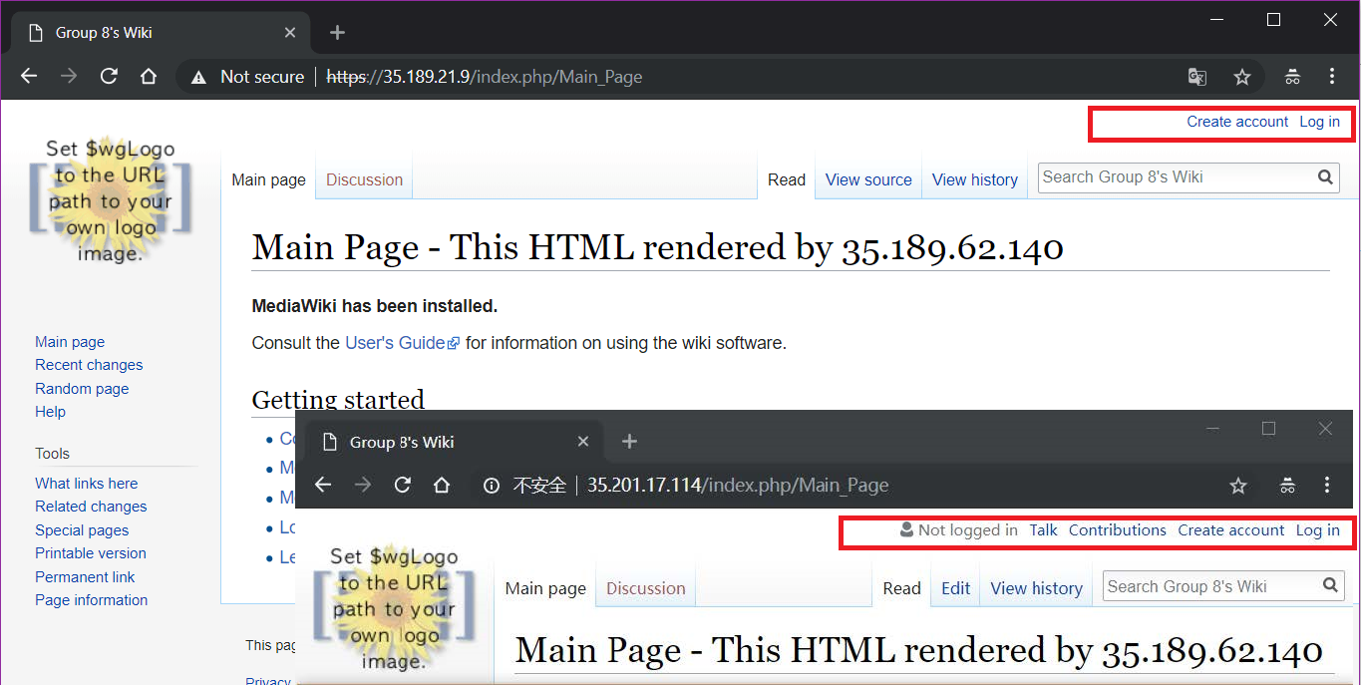

If you search for one page that does not exists it shows one line but no “create page” link;

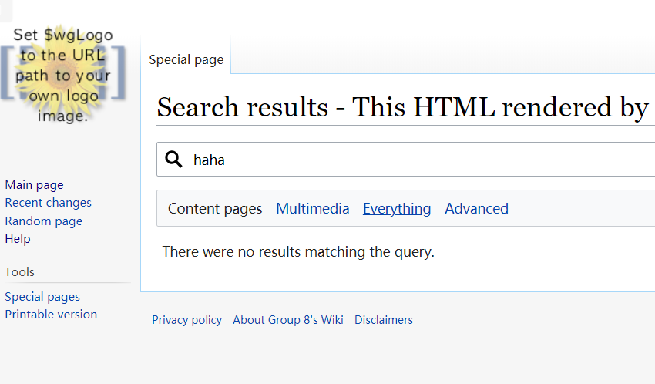

To avoiding bots registering, we add the google reCAPTCHA v2 to avoid bots or scripts signing up;

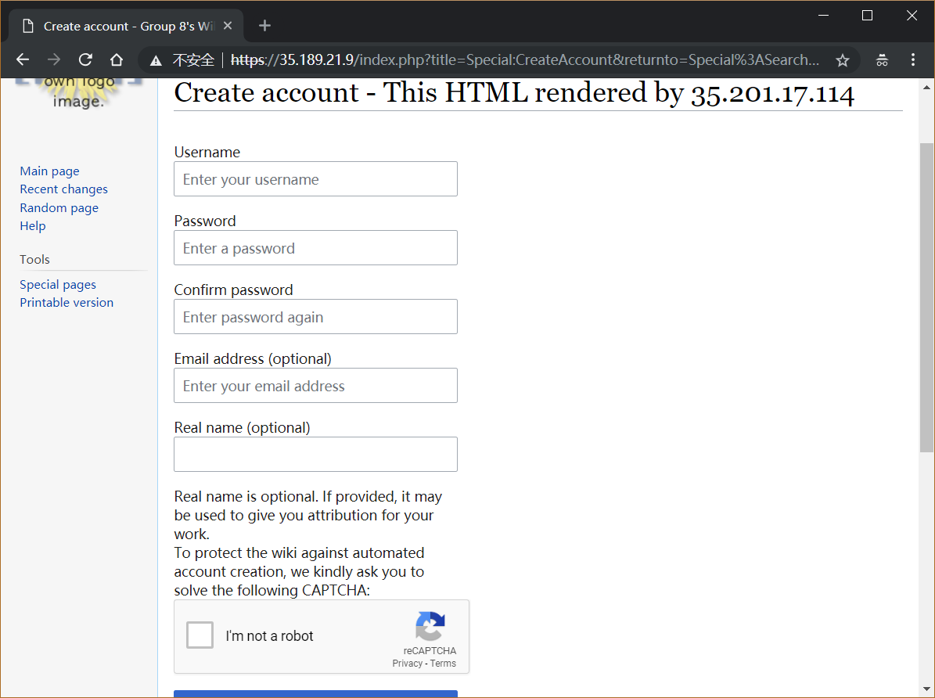

For internet security, we add the HTTPS(SSL/TLS) encryption (with a self-signed certification). But we used a self-signed Certification, so please press the “Proceed to **.**.**.** (unsafe)” to ignore the untrusted SSL notification.

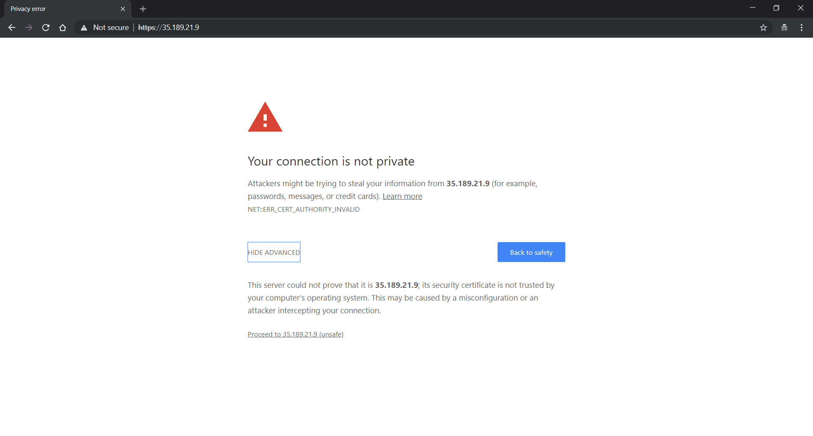

For database safety, we used Google Cloud SQL for the centralized Database system, which has better performance and stability than just install MySQL on an instance. We use Google Cloud SQL daily backup at 0:00(GMT)



And we print another backup which is created during implementation.



Another thing is that ip control of the database, we implemented it, and this is a test:

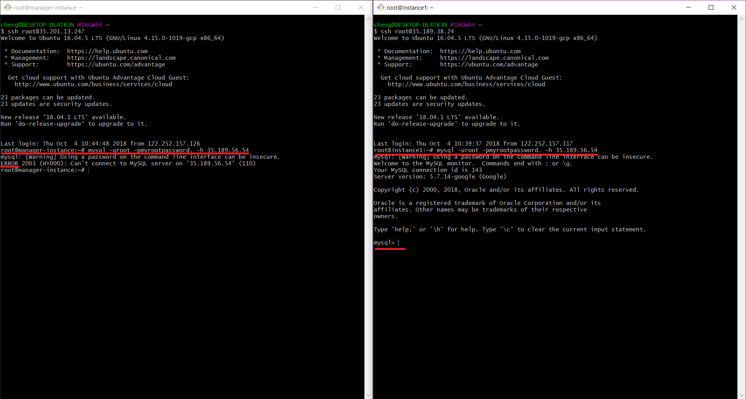

The left one does not have the permission, and the right one has the permission.